# Question

Given a set of words **(without duplicates)**, find all [word squares](https://en.wikipedia.org/wiki/Word_square) you can build from them.

A sequence of words forms a valid word square if the *k*th row and column read the exact same string, where 0 ≤ *k* < max(numRows, numColumns).

For example, the word sequence ["ball","area","lead","lady"] forms a word square because each word reads the same both horizontally and vertically.

b a l l

a r e a

l e a d

l a d y

**Note:**

1. There are at least 1 and at most 1000 words.
2. All words will have the exact same length.
3. Word length is at least 1 and at most 5.
4. Each word contains only lowercase English alphabet a-z.

**Example 1:**

**Input:**

["area","lead","wall","lady","ball"]

**Output:**

[

[ "wall",

"area",

"lead",

"lady"

],

[ "ball",

"area",

"lead",

"lady"

]

]

**Explanation:**

The output consists of two word squares. The order of output does not matter (just the order of words in each word square matters).

**Example 2:**

**Input:**

["abat","baba","atan","atal"]

**Output:**

[

[ "baba",

"abat",

"baba",

"atan"

],

[ "baba",

"abat",

"baba",

"atal"

]

]

**Explanation:**

The output consists of two word squares. The order of output does not matter (just the order of words in each word s

# Solution

Before diving into the solutions, it could be helpful to take a step back and clarify the requirements of the problem first.

Given a list of non-duplicate words, we are asked to construct all possible combinations of word squares. And here is the definition of ***word square***.



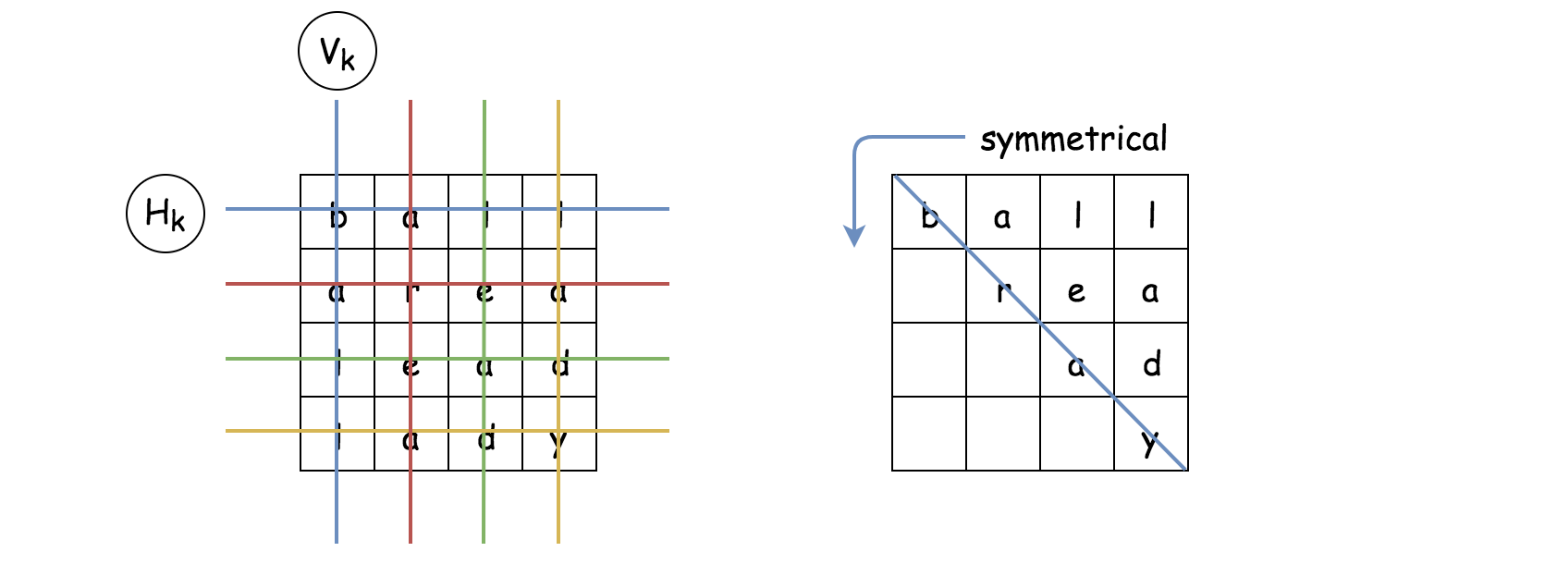

As we can see from the definition, for a word square with equal-sized row and column, the resulting letter matrix should be **symmetrical** across its diagonal.

In other words, if we know the upper-right part of the word square, we could infer its lower-left part, and vice versa. This symmetric property of the word square could also be interpreted as the **constraint** of the problem (as in the constraint programming), which could help us to narrow down the valid combinations.

#### **Algorithm: Backtracking**

Given a list of words, we are asked to find a combination of words upon with we could construct a word square. The backbone of the algorithm to solve the above problem could be surprisingly simple.

The idea is that we construct the word square **row by row** from top to down. At each row, we simply do trial and error, i.e. we try with one word, if it does not meet the constraint then we try another one.

As one might notice, the above idea of the algorithm is actually known as [backtracking](https://leetcode.com/explore/learn/card/recursion-ii/472/backtracking/2654/), which is often associated with recursion and DFS (Depth-First Search) as well.

Let us illustrate the idea with an example. Given a list of words [ball, able, area, lead, lady], we should pile up 4 words together in order to build a word square.

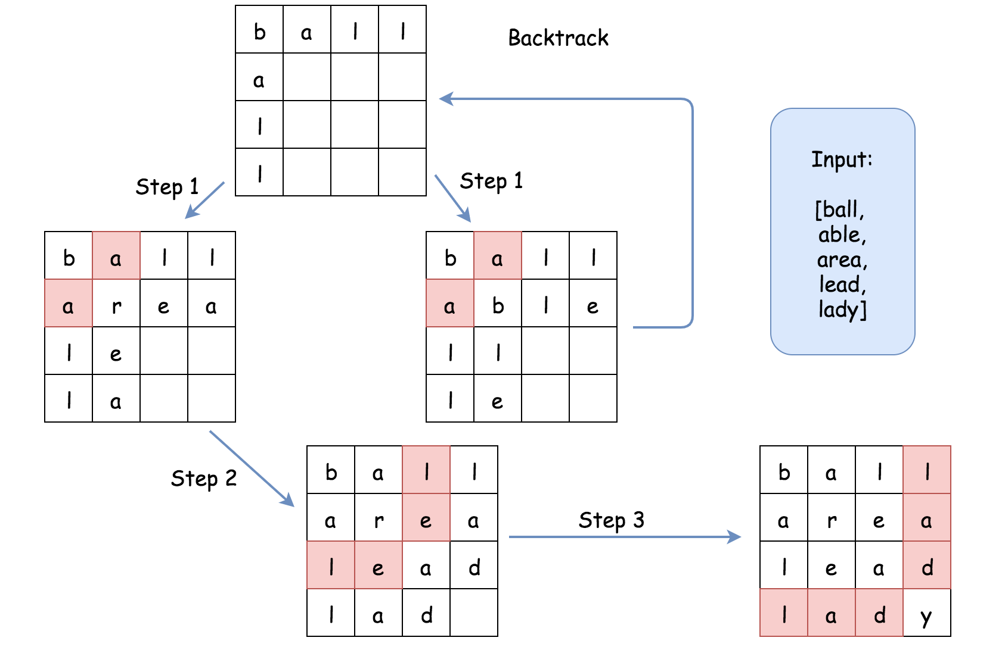

* Let us start with the word ball as the first word in the word square, i.e. the word that we would put in the first row.
* We then move on to the second row. Given the symmetric property of the word square, we now know the letters that we should fill on the first column of the second row. In other words, we know that the word in the second row should start with the prefix a.
* Among the list of words, there are two words with prefix a (i.e. able, area). Both of them could be the candidates to fill the second row of the square. We then should try both of them in the next step.
* In the next step (1), let us fill the second row with the word able. Then we could move on to the third row. Again, due to the symmetric property, we know that the word in the third row should start with the prefix ll. Unfortunately, we do not find any word start with ll. As a result, we could no longer move forwards. We then abandon this path, and **backtrack** to the previous state (with the first row filled).
* As an alternative next step (1), we could try with the word area in the second row. Once we fill the second row, we would know that in the next row, the word to be filled should start with the prefix le. And this time, we find the candidate (i.e. lead).
* As a result, in the next step (2), we fill the third row with the word lead. So on and so forth.
* At the end, if one repeats the above steps with each word as the starting word, one would exhaust all the possibilities to construct a valid word square.

One could follow the [code template of backtracking](https://leetcode.com/explore/learn/card/recursion-ii/472/backtracking/2793/) from our Explore card to implement the above algorithm. Here is one example.

|  |
| --- |
| class Solution:  def wordSquares(self, words: List[str]) -> List[List[str]]:  self.words = words  self.N = len(words[0])  results = []  word_squares = []  for word in words:  # try with every word as the starting word  word_squares = [word]  self.backtracking(1, word_squares, results)  return results  def backtracking(self, step, word_squares, results):  if step == self.N:  results.append(word_squares[:])  return  prefix = ''.join([word[step] for word in word_squares])  # find out all words that start with the given prefix  for candidate in self.getWordsWithPrefix(prefix):  # iterate row by row  word_squares.append(candidate)  self.backtracking(step+1, word_squares, results)  word_squares.pop()  def getWordsWithPrefix(self, prefix):  for word in self.words:  if word.startswith(prefix):  yield word |

At the first glance of the code, the problem does not seem to be as daunting as it is labeled. Actually if one could come up the skeleton of code in the interview, it would be fair to say that one has scored the interview.

The above implementation is correct and would pass most of the test cases in the online judge. However, it would run into Time Limit Exceeded exception for certain test cases with large input. But, there is no need for dismay, since we've already figured out the hard part of the algorithm. We just need to iron out the last bit of optimization which actually could be a followup question during the interview.

#### **Approach 1: Backtracking with HashTable**

**Intuition**

As one might notice in the above backtracking algorithm, the bottleneck lies in the function getWordsWithPrefix() which is to find all words with the given prefix. At each invocation of the function, we were iterating through the entire input list of words, which is of linear time complexity \mathcal{O}(N)O(*N*).

One of the ideas to optimize the getWordsWithPrefix() function would be to process the words beforehand and to build a data structure that could speed up the lookup procedure later.

As one might recall, one of the data structures that provide a fast lookup operation is called ***hashtable*** or dictionary. We could simply build a hashtable with all possible prefixes as keys and the words that are associated with the prefix as the values in the table. Later, given the prefix, we should be able to list all the words with the given prefix in constant time \mathcal{O}(1)O(1).

**Algorithm**

* We build upon the backtracking algorithm that we listed above, and tweak two parts.
* In the first part, we add a new function buildPrefixHashTable(words) to build a hashtable out of the input words.
* Then in the second part, in the function getWordsWithPrefix() we simply query the hashtable to retrieve all the words that possess the given prefix.

Here are some sample implementations. The idea is inspired by the post of [gabbu](https://leetcode.com/problems/word-squares/discuss/91360/3-Python-Solutions-with-very-detailed-explanations) in the discussion forum.

|  |
| --- |
| class Solution {  int N = 0;  String[] words = null;  HashMap<String, List<String>> prefixHashTable = null;  public List<List<String>> wordSquares(String[] words) {  this.words = words;  this.N = words[0].length();  List<List<String>> results = new ArrayList<List<String>>();  this.buildPrefixHashTable(words);  for (String word : words) {  LinkedList<String> wordSquares = new LinkedList<String>();  wordSquares.addLast(word);  this.backtracking(1, wordSquares, results);  }  return results;  }  protected void backtracking(int step, LinkedList<String> wordSquares,  List<List<String>> results) {  if (step == N) {  results.add((List<String>) wordSquares.clone());  return;  }  StringBuilder prefix = new StringBuilder();  for (String word : wordSquares) {  prefix.append(word.charAt(step));  }  for (String candidate : this.getWordsWithPrefix(prefix.toString())) {  wordSquares.addLast(candidate);  this.backtracking(step + 1, wordSquares, results);  wordSquares.removeLast();  }  }  protected void buildPrefixHashTable(String[] words) {  this.prefixHashTable = new HashMap<String, List<String>>();  for (String word : words) {  for (int i = 1; i < this.N; ++i) {  String prefix = word.substring(0, i);  List<String> wordList = this.prefixHashTable.get(prefix);  if (wordList == null) {  wordList = new ArrayList<String>();  wordList.add(word);  this.prefixHashTable.put(prefix, wordList);  } else {  wordList.add(word);  }  }  }  }  protected List<String> getWordsWithPrefix(String prefix) {  List<String> wordList = this.prefixHashTable.get(prefix);  return (wordList != null ? wordList : new ArrayList<String>());  }  } |

**Complexity Analysis**

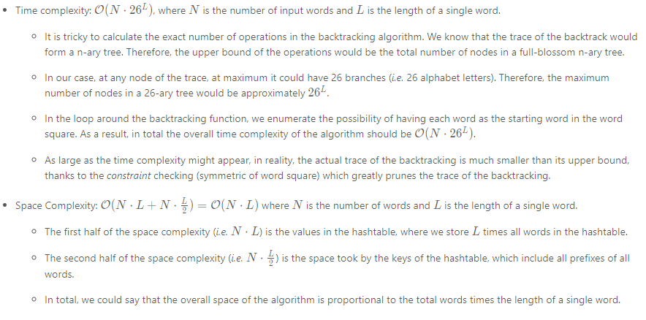

#### **Approach 2: Backtracking with Trie**

**Intuition**

Speaking about prefix, there is another data structure called **Trie** (also known as **prefix tree**), which could find its use in this problem.

In the above approach, we have reduce the time complexity of retrieving a list of words with a given prefix from the linear \mathcal{O}(N)O(*N*) to the constant time \mathcal{O}(1)O(1). In exchange, we have to spend some extra space to store all the prefixes of each words.

The Trie data structure provides a compact and yet still fast way to retrieve words with a given prefix.

In the following graph, we show an example on how we can build a Trie from a list of words.

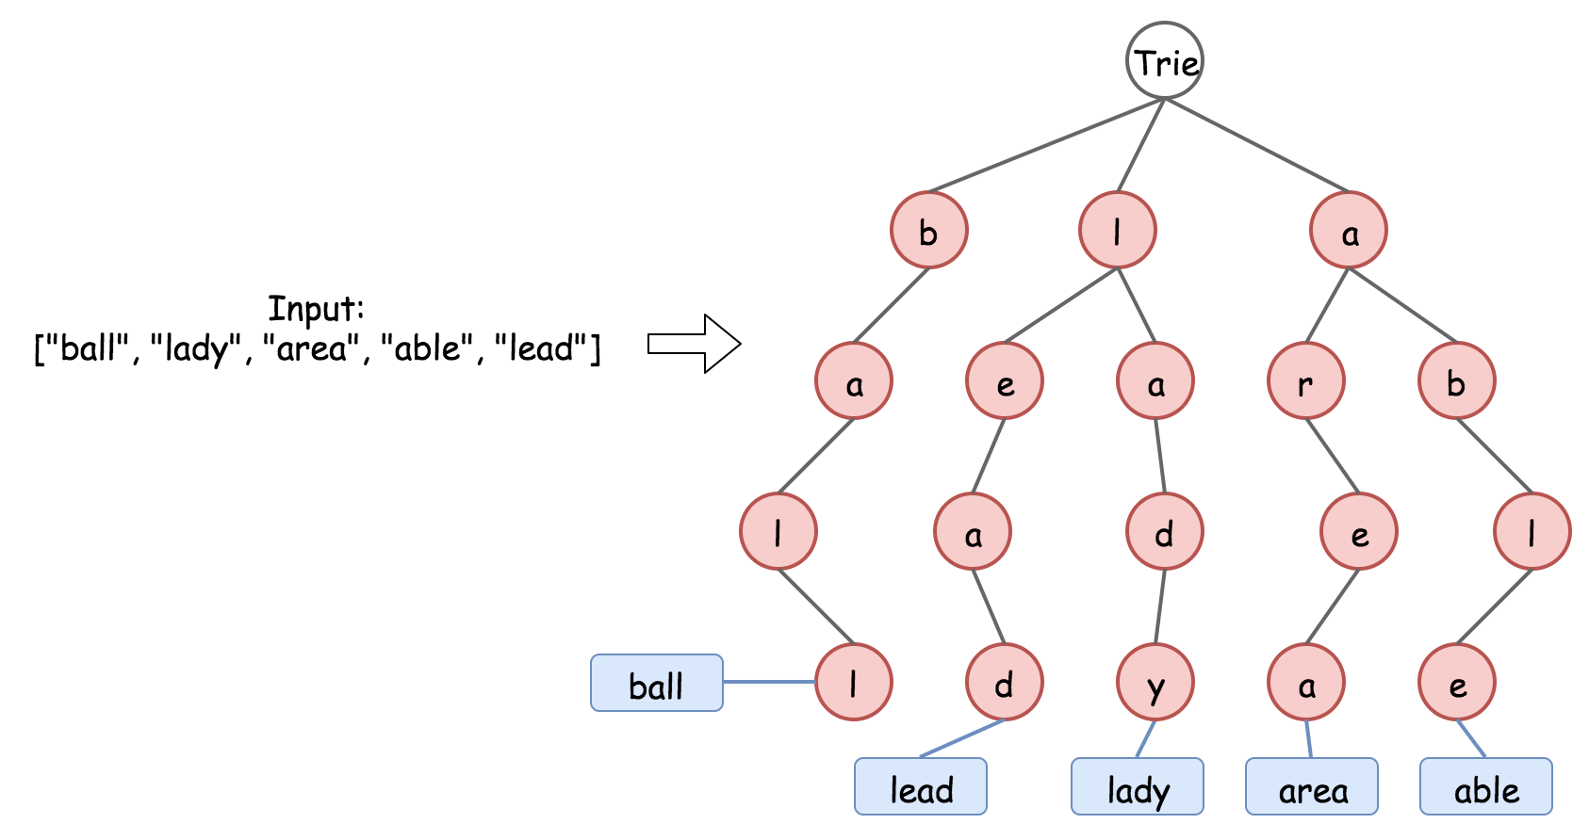

As we can see, basically Trie is a n-aray tree, where each node represents a character in a prefix. The Trie data structure is **compact** to store the prefixes, since it deduplicate the redundant prefixes, e.g. the prefixes of le and la would share one node. And yet it is still fast to retrieve words from the Trie. It takes \mathcal{O}(L)O(*L*) to retrieve a word, where L*L* is the length of the word, which is much faster than the brute-force enumeration.

**Algorithm**

* We build upon the backtracking algorithm that we listed above, and tweak two parts.
* In the first part, we add a new function buildTrie(words) to build a Trie out of the input words.
* Then in the second part, in the function getWordsWithPrefix(prefix) we simply query the Trie to retrieve all the words that possess the given prefix.

Here are some sample implementations. Note that, we tweak the Trie data structure a bit, in order to further optimize the time and space complexity.

* Instead of labeling the word at the leaf node of the Trie, we label the word at each node so that we don't need to perform a further traversal once we reach the last node in the prefix. This trick could help us with the time complexity.
* Instead of storing the actual words in the Trie, we keep only the index of the word, which could greatly save the space.

|  |
| --- |
| class TrieNode {  HashMap<Character, TrieNode> children = new HashMap<Character, TrieNode>();  List<Integer> wordList = new ArrayList<Integer>();  public TrieNode() {}  }  class Solution {  int N = 0;  String[] words = null;  TrieNode trie = null;  public List<List<String>> wordSquares(String[] words) {  this.words = words;  this.N = words[0].length();  List<List<String>> results = new ArrayList<List<String>>();  this.buildTrie(words);  for (String word : words) {  LinkedList<String> wordSquares = new LinkedList<String>();  wordSquares.addLast(word);  this.backtracking(1, wordSquares, results);  }  return results;  }  protected void backtracking(int step, LinkedList<String> wordSquares,  List<List<String>> results) {  if (step == N) {  results.add((List<String>) wordSquares.clone());  return;  }  StringBuilder prefix = new StringBuilder();  for (String word : wordSquares) {  prefix.append(word.charAt(step));  }  for (Integer wordIndex : this.getWordsWithPrefix(prefix.toString())) {  wordSquares.addLast(this.words[wordIndex]);  this.backtracking(step + 1, wordSquares, results);  wordSquares.removeLast();  }  }  protected void buildTrie(String[] words) {  this.trie = new TrieNode();  for (int wordIndex = 0; wordIndex < words.length; ++wordIndex) {  String word = words[wordIndex];  TrieNode node = this.trie;  for (Character letter : word.toCharArray()) {  if (node.children.containsKey(letter)) {  node = node.children.get(letter);  } else {  TrieNode newNode = new TrieNode();  node.children.put(letter, newNode);  node = newNode;  }  node.wordList.add(wordIndex);  }  }  }  protected List<Integer> getWordsWithPrefix(String prefix) {  TrieNode node = this.trie;  for (Character letter : prefix.toCharArray()) {  if (node.children.containsKey(letter)) {  node = node.children.get(letter);  } else {  // return an empty list.  return new ArrayList<Integer>();  }  }  return node.wordList;  }  } |

**Complexity Analysis**

